**Abstract**

The event planning industry has grown significantly, driven by increased demand for personalized, professionally managed events. Traditional event planning involves time-consuming, manual tasks such as coordinating with vendors, managing budgets, and tracking guest lists, often using disconnected tools. While digital platforms have simplified some aspects, they frequently lack the integration and customization needed to cater to diverse user needs.

Cosmic Occasions is designed to address these gaps by providing a centralized event planning platform that integrates all essential services. The platform offers a range of features, including budget management, vendor coordination, guest list tracking, scheduling, and real-time updates, all within a user-friendly interface. Cosmic Occasions focuses on user experience, offering customizable options that allow users to tailor the platform to their specific event requirements.

By automating repetitive tasks and providing a secure, scalable solution, Cosmic Occasions aims to reduce the stress of event planning and make the process more efficient and enjoyable. It also facilitates integration with third-party services, such as catering and photography, enabling a comprehensive, all-in-one event planning experience for both personal and corporate events.

**Table of Contents**

|  |  |  |
| --- | --- | --- |
| Sr. No. | Section | Page No. |
| 1 | Introduction | 3 |
| 2 | Problem Definition and Requirements | 4 |
| 3 | Proposed Design / Methodology | 6 |
| 4 | Results & Contribution | 7 |
| 6 | References | 9 |

1. **Introduction**
   1. **Background**

The event planning industry has grown exponentially over the past decade, reflecting the increasing demand for personalized and professionally managed events. Traditionally, event planning involved labor-intensive tasks such as coordinating with vendors, managing budgets, and keeping track of guest lists manually. This process was often stressful and inefficient, requiring planners to use multiple disconnected tools.

The rise of digital platforms has simplified some of these tasks; however, many existing solutions lack the integration and customization required to fully cater to a diverse audience. Cosmic Occasions is designed to address these shortcomings by offering a centralized event planning platform that integrates all essential services into one seamless experience. It goes beyond basic planning by including an expense tracker and offering all-in-one services such as vendor management, guest list tracking, scheduling, and real-time updates.

* 1. **Objectives**
     + 1. **Develop a User-Centric Platform:** Create an intuitive, accessible, and aesthetically pleasing event planning website.
       2. **Comprehensive Features:** Provide all necessary tools, including budget management, vendor selection, scheduling, guest list management, and real-time updates.
       3. **Customization:** Enable users to personalize their event planning experience based on their unique requirements.
       4. **Integration with External Services:** Facilitate seamless integration with third-party services, including catering, photography, and venue booking.
       5. **Scalability:** Design the platform to scale, allowing for both small personal events and large corporate functions.
       6. **Security:** Ensure that the platform is secure, protecting user data and preventing unauthorized access.
  2. **Significance**

The significance of Cosmic Occasions lies in its potential to transform the event planning process. This platform aims to reduce the stress often associated with planning events by automating repetitive tasks and providing users with a centralized dashboard for all their needs. It is designed to cater to a broad audience, from individuals planning personal milestones to companies coordinating professional gatherings.

By offering a range of customizable features, the platform empowers users to tailor their event planning experience, ensuring that all their specific requirements are met. Additionally, integrating external services allows users to access a wide variety of resources directly from the platform, eliminating the need to juggle multiple tools.

**2. Problem Definition and Requirements**

**2.1 Problem Statement**

1. **Lack of Integration:** Existing event planning tools often focus on isolated tasks (e.g., guest list management, vendor selection) without providing a unified platform that integrates all necessary services, making the process fragmented and inefficient.
2. **Budget Management Difficulties:** Event planners struggle to monitor and control expenses in real time, leading to budget overruns due to the lack of an integrated expense tracking system.
3. **Manual Vendor Coordination:** Coordinating with vendors, negotiating prices, and managing bookings manually is time-consuming and prone to errors, especially when multiple vendors are involved.
4. **Limited Customization:** Current event planning platforms offer limited options for personalizing events, resulting in a one-size-fits-all experience that doesn't meet the unique needs of different users.
5. **Inefficient Task Scheduling:** Planners face challenges in creating and managing detailed event schedules that avoid conflicts, delays, and miscommunications between vendors and attendees.
6. **Scattered Data Management:** Managing event-related data, such as guest lists, vendor contacts, and budgets, across multiple platforms or spreadsheets leads to disorganization and potential data loss.
7. **Poor User Experience:** Existing platforms often have clunky, unintuitive interfaces that complicate the planning process rather than simplifying it.
8. **Security Concerns:** Users need a secure platform to handle sensitive information such as personal details, financial transactions, and vendor contracts, but many existing solutions lack robust security measures.

**2.2 Software Requirements**

1. **Front-End Technologies:** HTML5, CSS3, JavaScript, React or Angular for creating a dynamic and responsive user interface.

**2.3 Hardware Requirements:**

1. **Web Server:** High-performance server to host the platform with adequate processing power, storage, and bandwidth.
2. **Hosting Services:** Cloud-based hosting with support for high traffic, database management, and security features.
3. **Backup Solutions:** Automatic data backup services to ensure data integrity and disaster recovery.

**3. Proposed Design**

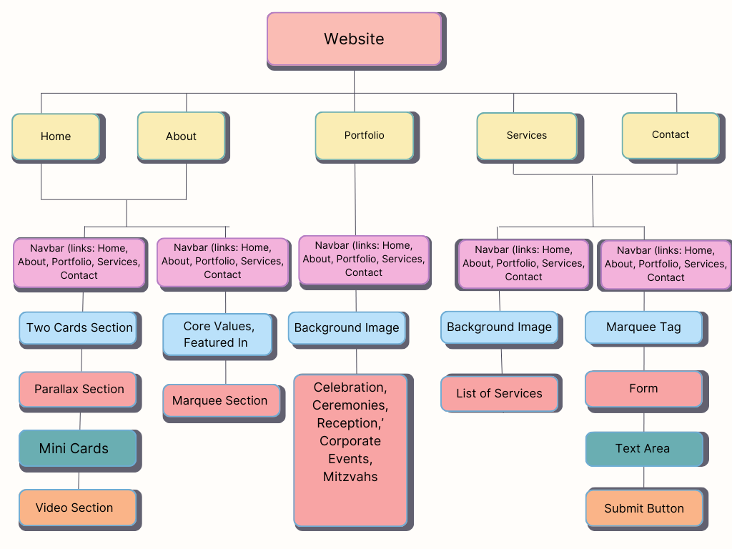

**Fig-3.1**

* 1. **Methodology**

**3.1.1 User-Centered Design:** Focus on user experience by testing the site with real users and iterating based on feedback.

**3.1.2 Responsive Design:** Ensure the website is fully responsive and works well on all devices.

**3.1.3 Regular Updates:** Regularly update the site with new content, blog posts, and event highlights to keep it fresh and engaging.

**4. Results & Contribution**

I was responsible for designing and developing the Home page and About page. My focus was on creating a user-friendly, visually appealing interface that effectively communicated the core services and values of the event management company.

* 1. **Home Page Development**

Key features included:

1. Responsive Navigation Bar
2. Video Integration
3. Footer and Branding

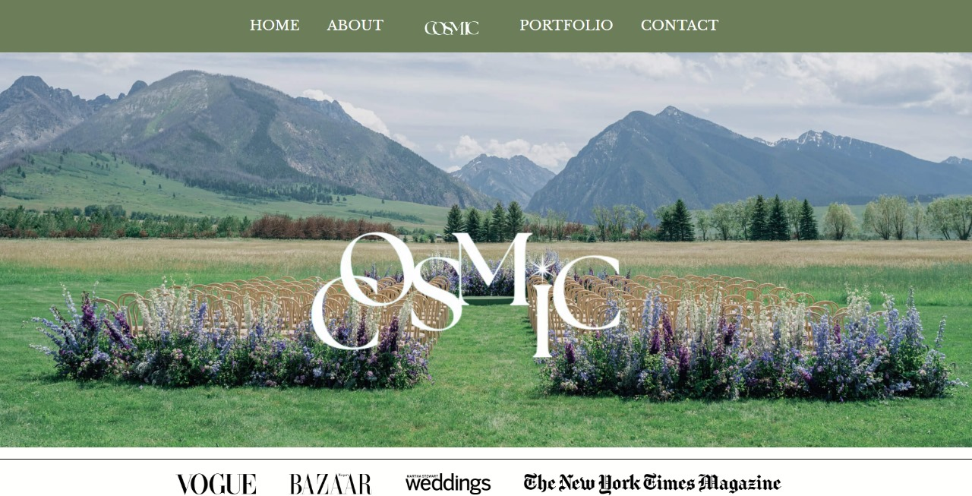

**Fig-4.1**

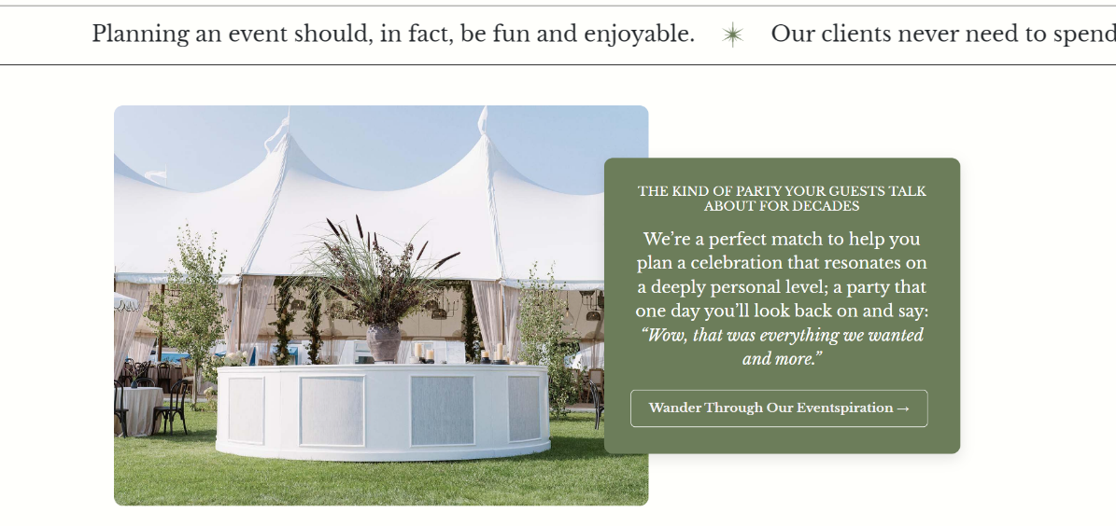

**Fig-4.2**

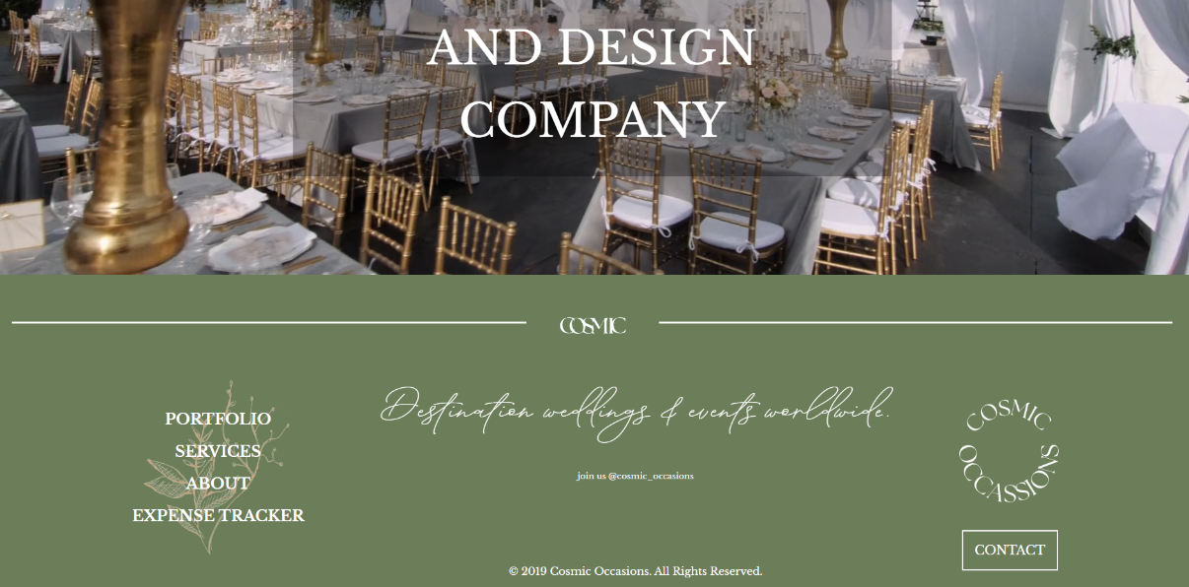

**Fig-4.3**

* 1. **About Page Development**

Key features included:

1. Brand Storytelling
2. Core Values and Features
3. Responsive Design

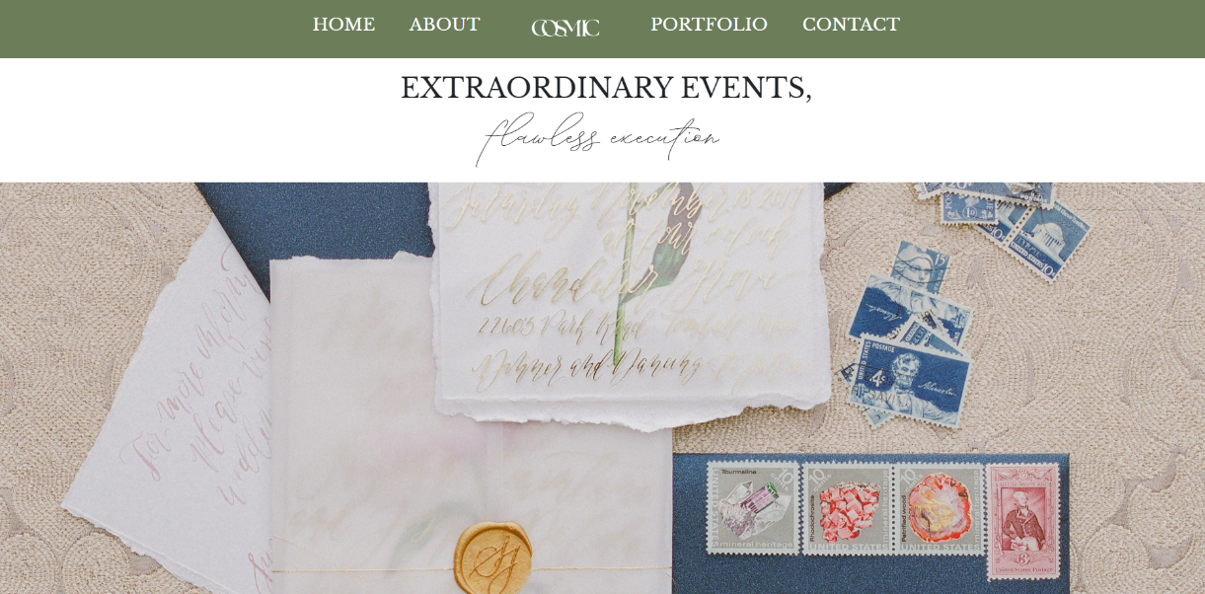

**Fig-4.4**

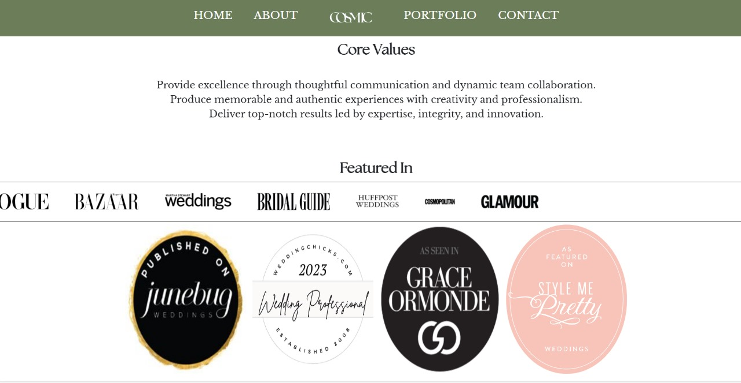

**Fig-4.5**

**5. References:**

**5.1 Books**

1. Learning web designing: a beginner's guide to HTML, CSS, JavaScript, and graphics by Niederst Robbins,Oreilly Publications, 2018

**5.2 Links:**

1. [**marcyblum.com**](http://marcyblum.com)
2. [**prestonbailey.com**](http://prestonbailey.com)